Perimeter and Area Quiz Review

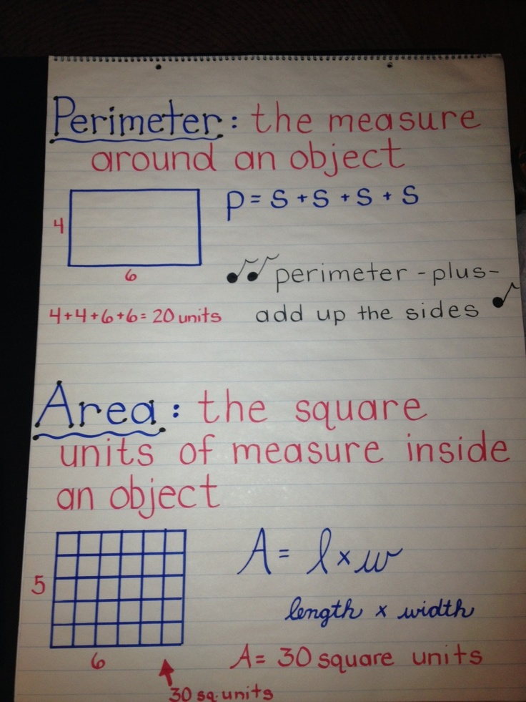
Perimeter Word Problem Examples:

Lexi wanted to build a fence around her house. Her yard has only four sides and each side is 15 feet long. What is the perimeter?

Terra is making a blanket for her sister. She needs to figure out what the perimeter would be to buy the material. If the blanket has four sides and the length is 8 feet and the width is 5 feet. What is the perimeter?

Area Word Problem Examples:
Joel has cookies. The length of each cookie is 7 cm and the width is 5 cm. Find the area of the cookies.
Aaron built a box with the length of 12 inches and a width of 6 inches. Find the area of the box.

Use the attached worksheet to practice perimeter and area.

