Telling Time Review Sheet

Look and practice the concepts on this sheet for our test on Wednesday, OCTOBER 9th . Students will be able to use a clock during the test.

Be able to write times two different ways.

Telling Time to the Hour

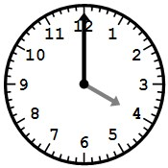

Telling Time to the Quarter

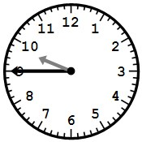
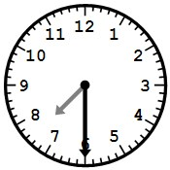

Telling Time to the Five Minute Interval
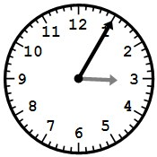
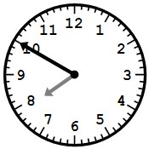

Telling Time to the One Minute Interval

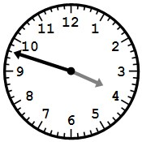
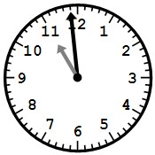

Elapsed Time
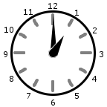
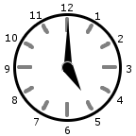
How much time has gone by between the times on the first and second clocks?

___________________

_____________________ ______________________

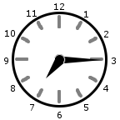
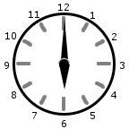
How much time has gone by between the times on the first and second clocks?

___________________

______________________ _____________________

Word Problems

Oliver started looking for his missing cat at 2:40. If he found it at 6:00, how long did he spend looking?
Gwen and her friends left for the park at 6:55. If they got back at 9:55, how long were they at the park?
Find the Ending Time

Paul spent 2 hours and 45 minutes working on homework. If he started at 5:20, what time was it when he finished?
Victor spent 2 hours and 15 minutes reading a book. If he started reading at 1:35, what time was it when he finished?

