Multiplication Facts:
Know facts 0-10
(May have a few 11 facts.)
Factor- one of the numbers multiplied.
Product- the number obtained when multiplying.

Review strategies in your journal for each factor we learned!
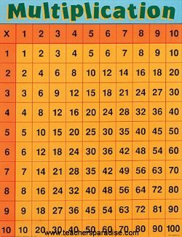

Multiplication Array:
Know how to show multiplication in an array strategy.
Array- objects arranged in rows and columns.
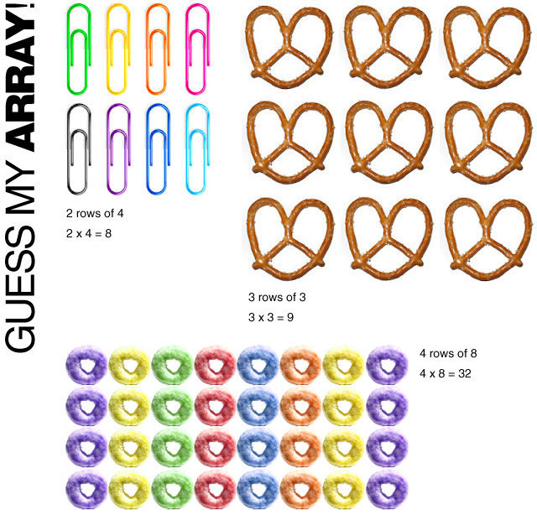
Multiplication Sentences: Use an array to write a multiplication sentence.

a. _____ +_______+______=________

b.________ x________=__________

Multiplication Stories: Find facts or clues to help you solve multiplication stories.

1. Each of Cheryl’s 10 model trucks has 6 wheels. If she has to buy new wheels for all of her model trucks, how many wheels will she have to buy?
2. The petroleum nut tree grows in Asian rain forests. Its seeds contain oil, which is burned as fuel. One petroleum nut tree produces 3 tablespoons of oil each day. How much oil does one petroleum nut tree produce each week?

Multiplying with 3 Factors:
(3x2)x5=
1x(4x8)=
9x(3x4)=
3. Jim, Angie, and Ryan each made 2 rain forest picture books. They drew 5 pictures in each book. How many pictures did they draw in all?

